**Supplementary Information for:**

**Two-stage Adaptive Modelling Framework for Long-term Monthly Operation of a Multi-purpose Reservoir for Regulating Environmental Flows**

**Ruby Jose1and Srinivasan K2**

1Former Research Scholar, 2Professor (Retd.), Department of Civil Engineering, Indian Institute of Technology Madras, Chennai – 600036.

Corresponding author: Ruby Jose. J ([rubyphdwork@gmail.com](mailto:rubyphdwork@gmail.com))

Address: Department of Civil Engineering, IIT Madras, Chennai 600036, India.

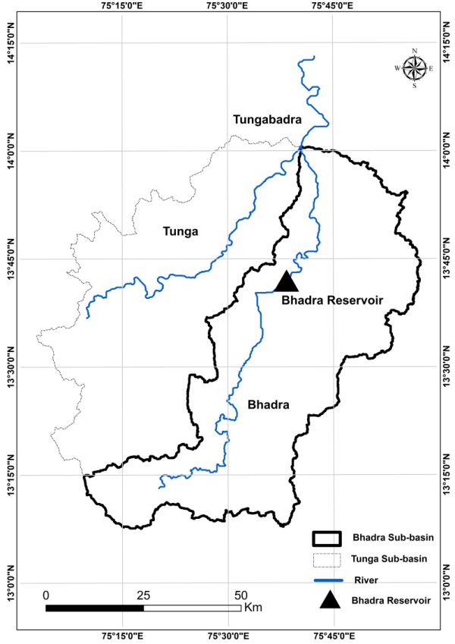

Fig. S-1.1: Location map of the Bhadra river-reservoir system

(Delineated from SRTM DEM using ARC-GIS 10.2.2)

Table S-1.1: Mean monthly inflows and monthly Irrigation target demands (×106m3).

|  |  |  |  |  |  |  |  |  |  |  |  |  |
| --- | --- | --- | --- | --- | --- | --- | --- | --- | --- | --- | --- | --- |
|  | *Jun* | *Jul* | *Aug* | *Sep* | *Oct* | *Nov* | *Dec* | *Jan* | *Feb* | *Mar* | *Apr* | *May* |
| *Mean Monthly*  *Inflow* | 243 | 771 | 820 | 323 | 209 | 100 | 48 | 27 | 15 | 10 | 11 | 18 |
| *Irrigation Target Demand* | 12 | 65 | 185 | 159 | 126 | 156 | 31 | 125 | 142 | 216 | 173 | 70 |

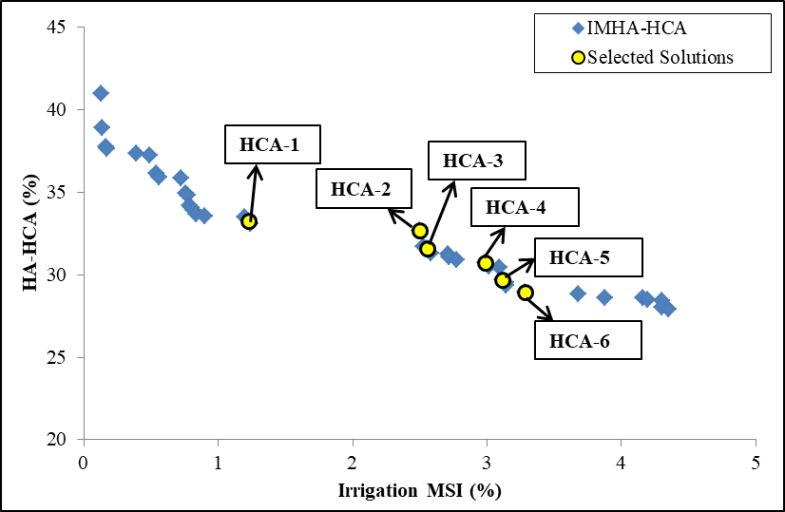

Fig. S**-**1.2: Pareto-front of the multi-objective optimization run IMHA-HCA

Table S-1.2: Optimal monthly E-flow targets for the five selected P-O solutions of

IMHA-HCA

|  |  |  |  |  |  |  |  |  |  |  |  |  |  |  |  |
| --- | --- | --- | --- | --- | --- | --- | --- | --- | --- | --- | --- | --- | --- | --- | --- |
| **Sol.** | **Irr**  **MSI**  **(%)** | **HA-HCA (%)** | **Year type** | **Optimal monthly E-flow targets (×106m3)** | | | | | | | | | | | |
| **J** | **J** | **A** | **S** | **O** | **N** | **D** | **J** | **F** | **M** | **A** | **M** |
| IMHA-HCA-1 | 1.22 | 33.28 | D | 78 | 254 | 246 | 132 | 63 | 30 | 14 | 27 | 15 | 10 | 11 | 18 |
| N | 73 | 231 | 246 | 97 | 63 | 30 | **24** | 27 | 15 | 10 | 11 | 18 |
| W | **114** | 231 | **631** | 97 | 63 | 30 | 14 | 27 | 15 | 10 | 11 | 18 |
| HCA-2 | 2.50 | 32.67 | D | 73 | 231 | **451** | 97 | 63 | 30 | 14 | 27 | 15 | 10 | 11 | 18 |
| N | 73 | 239 | 246 | 100 | 67 | 30 | **25** | 27 | 15 | 10 | 11 | 18 |
| W | 73 | **648** | 271 | 107 | 77 | 40 | **22** | 27 | 15 | 10 | 11 | 18 |
| HCA-3 | 2.55 | 31.62 | D | 73 | 231 | **451** | 97 | 63 | 30 | 14 | 27 | 15 | 10 | 11 | 18 |
| N | 73 | 231 | 246 | 97 | 63 | 30 | **39** | 27 | 15 | 10 | 11 | 18 |
| W | 73 | **655** | 271 | 97 | **105** | **51** | 17 | 27 | 15 | 10 | 11 | 18 |
| HCA-4 | 2.99 | 30.72 | D | 73 | 247 | **451** | 97 | 63 | 30 | 14 | 27 | 15 | 10 | 11 | 18 |
| N | 78 | 231 | 246 | 97 | 63 | 30 | **40** | 27 | 15 | 10 | 11 | 18 |
| W | 75 | 293 | **607** | 97 | **121** | **42** | 14 | 27 | 15 | 10 | 11 | 18 |
| HCA-5 | 3.12 | 29.7 | D | 85 | 231 | **459** | 97 | 63 | 30 | 14 | 27 | 15 | 10 | 11 | 18 |
| N | 73 | 231 | 279 | 97 | 63 | 30 | **39** | 27 | 15 | 10 | 11 | 18 |
| W | 75 | 278 | **590** | 116 | 71 | **53** | 14 | 27 | 15 | 10 | 11 | 18 |

Table S-1.3: Performance of the five selected P-O solutions of IMHA-HCA in terms of Irrigation MSI and average monthly Irrigation deficits.

|  |  |  |  |  |  |  |  |  |  |  |  |  |  |  |
| --- | --- | --- | --- | --- | --- | --- | --- | --- | --- | --- | --- | --- | --- | --- |
| **Solution** | **HA-HCA** | **Irrigation MSI** | **Average monthly Irrigation deficits** | | | | | | | | | | | |
| J | J | A | S | O | N | D | J | F | M | A | M |
| **HCA - 1** | 33.28 | 1.22 | 8 | 9 | 7 | 9 | 10 | 3 | 3 | 3 | 9 | 9 | 12 | 12 |
| **HCA - 2** | 32.67 | 2.50 | 12 | 12 | 5 | 4 | 4 | 3 | 4 | 3 | 10 | 12 | 15 | 19 |
| **HCA - 3** | 31.62 | 2.55 | 12 | 13 | 5 | 6 | 5 | 3 | 4 | 3 | 11 | 12 | 17 | 17 |
| **HCA - 4** | 30.72 | 2.99 | 13 | 13 | 4 | 7 | 8 | 4 | 4 | 4 | 12 | 13 | 18 | 17 |
| **HCA - 5** | 29.70 | 3.12 | 12 | 12 | 4 | 11 | 10 | 4 | 5 | 4 | 12 | 14 | 18 | 20 |

*All figures are in %

Table S-1.4 Performance comparison of the selected P-O solutions from IMEM-HCA (two-stage) model and the corresponding solutions from IMHA-HCA (stage-1/single-stage) model.

|  |  |  |  |  |  |  |  |  |  |  |  |  |  |  |  |  |  |  |  |  |
| --- | --- | --- | --- | --- | --- | --- | --- | --- | --- | --- | --- | --- | --- | --- | --- | --- | --- | --- | --- | --- |
|  | **HA-HCA ≤ 33.28** | | | | **HA-HCA ≤ 32.67** | | | | **HA-HCA ≤ 31.62** | | | | **HA-HCA ≤ 30.72** | | | | **HA-HCA ≤ 29.70** | | | |
|  | **IMHA** | | **IMEM** | | **IMHA** | | **IMEM** | | **IMHA** | | **IMEM** | | **IMHA** | | **IMEM** | | **IMHA** | | **IMEM** | |
| **Irrigation MSI** | 1.22 | | 1.78 | | 2.50 | | 1.28 | | 2.55 | | 3.29 | | 2.99 | | 2.53 | | 3.12 | | 3.59 | |
| **E-flow MSI** | 7.22 | | 6.27 | | 8.35 | | 8.03 | | 8.29 | | 5.39 | | 8.35 | | 5.84 | | 8.65 | | 5.26 | |
| **Month** | **Average monthly deficits** | | | | | | | | | | | | | | | | | | | |
| **Irr** | **Ef** | **Irr** | **Ef** | **Irr** | **Ef** | **Irr** | **Ef** | **Irr** | **Ef** | **Irr** | **Ef** | **Irr** | **Ef** | **Irr** | **Ef** | **Irr** | **Ef** | **Irr** | **Ef** |
| Jun | 8 | 20 | 10 | 25 | 12 | 20 | 7 | 27 | 12 | 20 | 14 | 16 | 13 | 20 | 12 | 19 | 12 | 20 | 12 | 14 |
| Jul | 9 | 20 | 14 | 27 | 12 | 20 | 10 | 29 | 13 | 20 | 18 | 23 | 13 | 20 | 13 | 27 | 12 | 20 | 14 | 20 |
| Aug | 7 | 5 | 6 | 8 | 5 | 3 | 4 | 9 | 5 | 3 | 5 | 8 | 4 | 1 | 4 | 9 | 4 | 1 | 4 | 6 |
| Sep | 9 | 3 | 2 | 3 | 4 | 4 | 6 | 13 | 6 | 4 | 10 | 16 | 7 | 4 | 6 | 13 | 11 | 5 | 8 | 11 |
| Oct | 10 | 6 | 4 | 5 | 4 | 4 | 3 | 7 | 5 | 4 | 4 | 6 | 8 | 7 | 4 | 8 | 10 | 7 | 5 | 7 |
| Nov | 3 | 0 | 6 | 9 | 3 | 3 | 2 | 5 | 3 | 3 | 3 | 4 | 4 | 3 | 3 | 6 | 4 | 4 | 4 | 5 |
| Dec | 3 | 2 | 1 | 1 | 4 | 4 | 2 | 4 | 4 | 4 | 3 | 5 | 4 | 5 | 3 | 7 | 5 | 5 | 2 | 3 |
| Jan | 3 | 1 | 0 | 1 | 3 | 4 | 4 | 9 | 3 | 4 | 7 | 9 | 4 | 4 | 4 | 10 | 4 | 4 | 7 | 8 |
| Feb | 9 | 6 | 2 | 4 | 10 | 9 | 2 | 4 | 11 | 11 | 5 | 6 | 12 | 10 | 3 | 7 | 12 | 11 | 5 | 5 |
| Mar | 9 | 8 | 4 | 6 | 12 | 14 | 3 | 6 | 12 | 13 | 10 | 14 | 13 | 13 | 8 | 16 | 14 | 13 | 8 | 8 |
| Apr | 12 | 13 | 11 | 23 | 15 | 18 | 7 | 18 | 17 | 18 | 14 | 20 | 18 | 18 | 12 | 13 | 18 | 18 | 14 | 17 |
| May | 12 | 20 | 9 | 21 | 19 | 20 | 13 | 34 | 17 | 18 | 16 | 22 | 17 | 18 | 17 | 21 | 20 | 20 | 19 | 25 |

*All figures are in %

It is observed from Table S-1.4 that the model runs IMEM-HCA-33.28, IMEM-HCA-31.62 and IMEM-HCA-29.70 yield lower E-flow MSI, although there is an increase in their Irrigation MSI, when compared with their corresponding IMHA-HCA. In the other two model runs IMEM-HCA-32.67 and IMEM-HCA-30.72, both E-flow MSI and Irrigation MSI are lower than their respective counterparts from IMHA-HCA. However, the monthly average E-flow deficits of IMEM-HCA are higher than the acceptable limit (> 20%) in two to four months between April and July, for all the five solutions (Table S-1.4). However, if a limiting constraint on E-flow deficit is included in stage-2, the Irrigation deficits that are currently in reasonable limits will shoot up. Hence, in the best interest to sustain the crop yield during the trade-off between Irrigation and E-flows, it is ignored.

At higher HA-HCA limits of 33.28% and 32.67%, the reduction in E-flow MSI is somewhat less in case of IMEM-HCA whereas it is significant in case of lower HA-HCA limits (31.62%, 30.72% and 29.70%). This difference in performance may be attributed to the varying pattern in the monthly optimal E-flow targets derived from IMHA-HCA (Table S-1.2). However, these differences in E-flow MSIs are not reflected in the monthly average deficits (Table 5.12). This may be because the average monthly deficits estimated over the entire simulation period tend to mask the effect of critical period deficits. On the other hand, the MSI is an integrated performance measure that reflects the overall performance of the reservoir operation, taking the severe deficits also into account.

Table S-1.5: Attributes pertaining to the simulated reservoir operation of IMHA-HCA-31.62 and IMEM-HCA-31.62 during the 26-month critical drought from June 2002 to July 2004.

|  |  |  |  |  |  |  |  |  |  |  |  |
| --- | --- | --- | --- | --- | --- | --- | --- | --- | --- | --- | --- |
| **Month** | $$R_{IR,i,j}^{T}$$ | $$R_{ER,k,j}^{T}$$ | **IMHA-HCA-31.62** | | | | **IMEM-HCA-31.62** | | | | |
| $$R_{ER i,j}$$ | $$R_{IR i,j}$$ | **NID** | **NED** | | $$R_{ER i,j}$$ | $$R_{IR i,j}$$ | **NID** | **NED** |
|
| Jun | 73 | 12 | 12 | 9 | 0.23 | 0.84 | | 20 | 7 | 0.43 | 0.72 |
| Jul | 231 | 65 | 36 | 50 | 0.23 | 0.84 | | 176 | 45 | 0.32 | 0.24 |
| Aug | 452 | 185 | 116 | 143 | 0.22 | 0.74 | | 195 | 112 | 0.39 | 0.57 |
| Sept | 97 | 159 | 97 | 139 | 0.13 | 0.00 | | 38 | 107 | 0.33 | 0.61 |
| Oct | 63 | 126 | 63 | 107 | 0.15 | 0.00 | | 36 | 97 | 0.23 | 0.42 |
| Nov | 30 | 156 | 30 | 135 | 0.13 | 0.00 | | 20 | 127 | 0.19 | 0.34 |
| Dec | 14 | 31 | 14 | 26 | 0.15 | 0.00 | | 9 | 25 | 0.20 | 0.37 |
| Jan | 27 | 125 | 27 | 108 | 0.14 | 0.00 | | 16 | 97 | 0.22 | 0.41 |
| Feb | 15 | 142 | 2 | 109 | 0.23 | 0.84 | | 9 | 113 | 0.20 | 0.37 |
| Mar | 10 | 216 | 2 | 165 | 0.23 | 0.84 | | 5 | 132 | 0.39 | 0.53 |
| Apr | 11 | 173 | 2 | 72 | 0.58 | 0.84 | | 9 | 118 | 0.32 | 0.24 |
| May | 18 | 70 | 3 | 10 | 0.86 | 0.84 | | 13 | 47 | 0.33 | 0.24 |
| June | 73 | 12 | 12 | 9 | 0.23 | 0.84 | | 55 | 8 | 0.32 | 0.24 |
| July | 231 | 65 | 36 | 50 | 0.23 | 0.84 | | 176 | 45 | 0.32 | 0.24 |
| Aug | 452 | 185 | 352 | 152 | 0.18 | 0.22 | | 342 | 126 | 0.32 | 0.24 |
| Sept | 97 | 159 | 15 | 122 | 0.23 | 0.84 | | 74 | 109 | 0.32 | 0.24 |
| Oct | 63 | 126 | 10 | 96 | 0.23 | 0.84 | | 48 | 86 | 0.32 | 0.24 |
| Nov | 30 | 156 | 5 | 120 | 0.23 | 0.84 | | 23 | 107 | 0.32 | 0.24 |
| Dec | 14 | 31 | 2 | 24 | 0.23 | 0.84 | | 11 | 21 | 0.32 | 0.24 |
| Jan | 27 | 125 | 4 | 96 | 0.23 | 0.84 | | 10 | 0 | 1.00 | 0.63 |
| Feb | 15 | 142 | 2 | 109 | 0.23 | 0.84 | | 6 | 0 | 1.00 | 0.56 |
| Mar | 10 | 216 | 2 | 26 | 0.88 | 0.84 | | 7 | 0 | 1.00 | 0.37 |
| Apr | 11 | 173 | 2 | 2 | 0.99 | 0.84 | | 4 | 0 | 1.00 | 0.64 |
| May | 18 | 70 | 3 | 42 | 0.41 | 0.84 | | 13 | 31 | 0.56 | 0.24 |
| June | 73 | 12 | 12 | 9 | 0.23 | 0.84 | | 55 | 8 | 0.32 | 0.24 |
| July | 231 | 65 | 138 | 52 | 0.20 | 0.40 | | 82 | 38 | 0.41 | 0.65 |

$R_{ER,k,j}^{T}$* - monthly varying E-flow release targets corresponding to HYT '' (Mm3); - monthly varying Irrigation release targets (Mm3); -reservoir releases towards E-flows (Mm3); - reservoir releases towards Irrigation(Mm3); NID- Normalized Irrigation Deficit; NED- Normalized E-flow Deficit.

During the 26-month drought period June 2002 to July 2004 (Table S-1.5), the initial reservoir storage in case of IMHA-HCA-31.62 is found to be in zone-1 (below the E-flow rule curve ${ERC}_{j}$, which is the most critical storage zone) for 18 out of 26 months, consisting of a six-month period (from February to July 2003) and a ten-month period (from September 2003 to June 2004). These 18 months encounter severe E-flow deficit of 84% each. Out of the remaining eight months, the initial storage lies in transition between zones 1 and 2 in three months that face a “less severe” E-flow deficit of 46% and in transition between 2 and 3 for five months with zero E-flow deficits, thus amounting to a meagre amount of “less severe” deficits, which is indicative from the corresponding SSND value in Table 1. On the other hand, the initial reservoir storage for IMEM-HCA-31.62 is located in zone-1 during 16 months, out of the drought period of 26 months, consisting of a fifteen-month period (from April 2003 to June 2004) with each month facing a uniform E-flow deficit of 24%. Thus, the deficits encountered by IMEM-HCA-31.62 are more distributed over the duration of the drought with lesser intensity, when compared with IMHA-HCA-31.62, resulting in lower E-flow MSI value.

As far as the Irrigation deficits during this 26-month drought event are concerned, IMHA-HCA-31.62 experiences “less severe” deficits (19% average) during the initial phase of the drought (June 2002 to March 2003). But, as the drought gets into more critical phase, the Irrigation deficits encountered during the two-month period from April to May 2003 are found to be “very severe” with 72% Irrigation deficit when the target demands for Irrigation are also quite high, resulting in very poor performance in that season (Table S-1.5). This is because very low initial storage is maintained in the reservoir during those two critical months, since higher releases are made during the earlier phase of the drought event. From June 2003 to February 2004 (9-month period), partial recovery is noted due to better inflows, with the average monthly deficit of 23%. Again, as the drought intensifies from March to April 2004, the Irrigation deficits turn out to be very severe (93%). A similar pattern is observed in case of IMEM-HCA-31.62 with the “less severe” drought periods experiencing 28% of Irrigation deficits. The critical drought periods are March 2003 and March 2004, each month facing 80% Irrigation deficit. Although the performance of IMHA-HCA-31.62 is markedly better than IMEM-HCA-31.62 in dealing with Irrigation requirements during periods of “severe” deficits, IMEM outperforms IMHA during periods of “less severe” deficits (Table 1). As a result, there is only a marginal difference in Irrigation MSI between the two model runs (Table S-1.4).